**Programming II**

**Fall 2021**

**Handong Global University**

****School of Entrepreneurship and ICT****

**Project plan**

**Team Members**

|  |  |
| --- | --- |
| Name | Student ID |
| Lee Seungyoo | 21300543 |
| Kim Joowon | 21300178 |
| Jung Suhui | 21900666 |
|  |  |

# Work hours

*Seungyoo*

*10.07 2 hours Figma frame*

*10.08 2 hours Figma screen composition.*

*10.10 2 hours Figma screen composition.*

*10.18 2 hours Apply the basic configuration.*

*10.21 1 hours Dialog study and apply*

*10.23 2 hours Make planning-dialog*

*10.26 1 hours Apply Expense*

*10.29 2 hours Main window interlocking*

*11.04 2 hours Database application.*

*11.07 2 hours Apply the modification code.*

*11.09 2 hours Change the category.*

*11.10 2 hours Add resource files and configure file systems.*

*11.17 1 hours Study qt*

*11.21 1 hours Study category*

*1124 1 hours Modify expense*

*11.26 2.5 hours Modify planning*

*11.30 2 hours Change to main window*

*12.02 2 hours Change to main window*

*12.05 1 hours 코드 정리*

*Joowon*

*10.09~10.10 5 hours Figma screen composition*

*10.26 3 hours Sql database study*

*10.30 3 hours Sql database practice*

*11.02 3 hours Sql database link to program*

*11.07 3 hours Add Expense to database*

*11.10 3 hours Fix error of adding data to Sql*

*11.20 2 hours Edit section study*

*11.27 5 hours Cmake Qt Chart package link*

*12.03 2.5 hours Make bar graph with Sql data*

*12.04 2.5 hours Find how to debug*

*Suhui*

*10.08 2 hours Figma screen composition.*

*10.09 2 hours Figma screen composition*

*10.20 2 hours Studying UI skills.*

*10.28 2 hours UI reconstruction suitable for functions.*

*10.29 3 hours Sql Database study*

*11.02 2 hours Database application.*

*11.09 3 hours Monitoring1 implementation*

*11.10 3 hours Monitoring2 implementation*

*11.20 2 hours Edit section study*

*11.22 2 hours Monitoring1 modification*

*11.25 2 hours UI study and practice*

*11.29 1.5 hours UI coding*

*11.30 3 hours UI coding*

*12.06 2 hours Modify UI to the main window.*

*Team Meeting time*

*10.10 1.5 hours Meeting for Mile3*

*11.11 1.5 hours Meeting for Mile4*

*11.21 1.5 hours Review what needs to be added or changed*

*11.28 1.5 hours Add monitoring function.*

*12.05 1.5 hours Connecting overall functions and trimming ui.*

*12.08 3 hours Meeting for Mile5*

# Screenshots of project management

*Attach screenshots of the project management system that you used. You need to show me with these screenshots that you really used project management.*

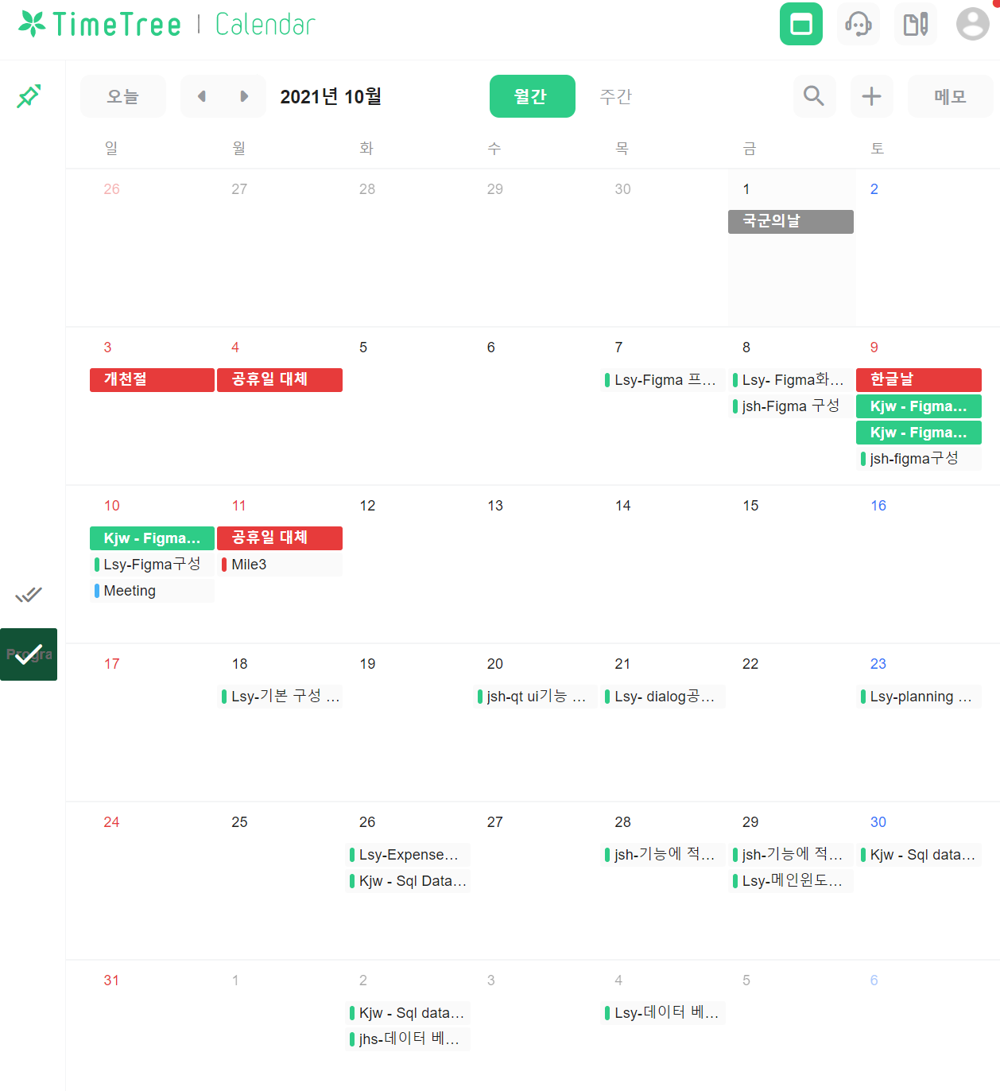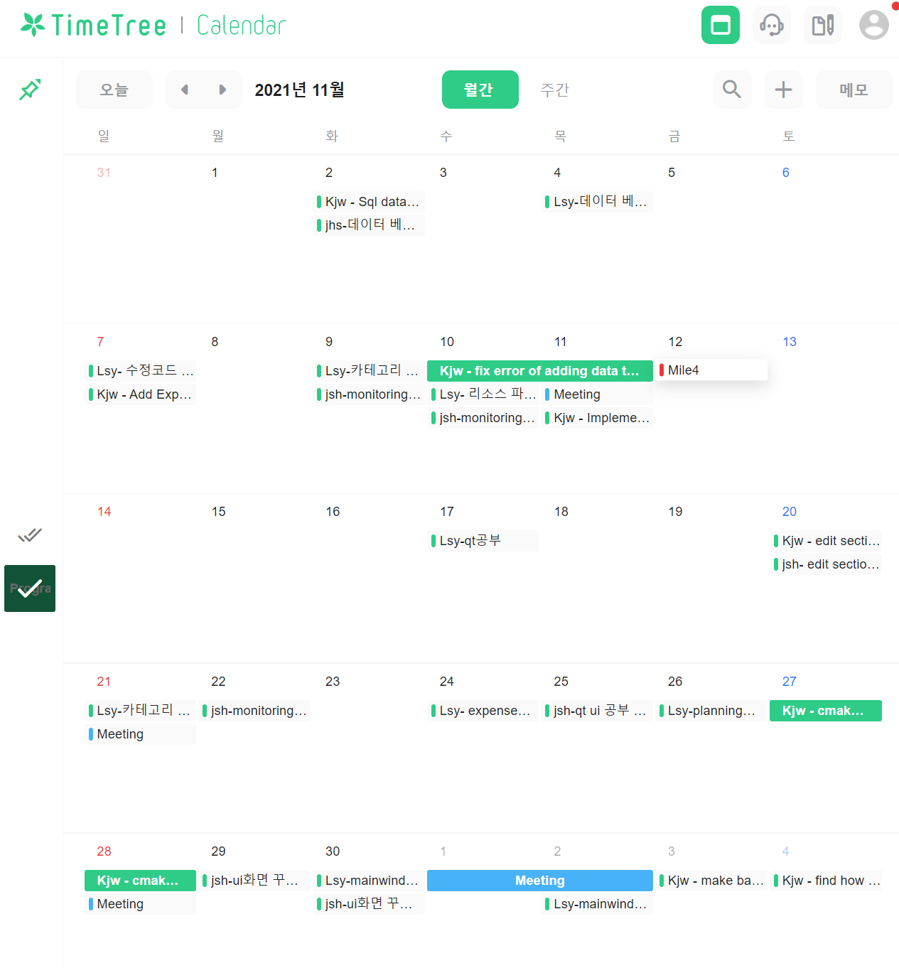

# *Screenshots of version control*

*Attach screenshots of the version control system that you used. You need to show me with these screenshots that you really used version control.*

# Work allocation

*How did you assign the tasks and responsibilities within your team? You need to specify tasks separately for each team member. Also, you need to specify which code parts were written by who (every team member had to write code).*

# Changes to project plan and UI design

*Does your final version fully implement what you stated in your project plan and in your UI design? If not, then report here the differences. Also, tell the reasons why you decided to do things differently.*

# Reflection

*What did you learn from this project assignment? What is something you learned that will be useful for you in the future in your opinion?*